

DEPARTMENT OF COMPUTER SCIENCE AND ENGINEERING
K. Lokesh Chandra
192425358
DDL Commands – CREATE, ALTER, DROP

AIM:
To Create, Alter, Drop, Rename, Truncate using Data Definition Language (DDL) statements.

Description:
Data Definition Language (DDL) statements are used to define the database structure or schema.
DDL Commands: Create, Alter, Drop, Rename, Truncate
- CREATE - to create objects in the database
- ALTER - alters the structure of the database
- DROP - delete objects from the database
- TRUNCATE - remove all records from a table, including all spaces allocated for the records are removed
- RENAME - rename an object

SYNTAX: CREATE TABLE
CREATE TABLE table_name (
column_name1 data_type, column_name2 data_type, column_name3 data_type,
....
);

ALTER A TABLE
To add a column in a table ALTER TABLE PATIENT ADD DISEASE datatype;

To delete a column in a table

ALTER TABLE PATIENT
DROP COLUMN DISEASE

DROP TABLE
DROP TABLE PATIENT;

TRUNCATE TABLE
TRUNCATE TABLE PATIENT;

Questions
1) Create a table named PATIENT with the following structure.
 | Column Name | Description | Data Type
1 | PatientID | Patient Identification Number | INT
2 | PatientName | Patient Name | VARCHAR(30)
3 | Gender | Gender of the Patient | CHAR(1)
4 | DOB | Date of Birth | DATE
5 | MobileNo | Mobile Number | BIGINT
6 | City | City of Residence | VARCHAR(30)

2) Create a table named DOCTOR with the following structure.
 | Column Name | Description | Data Type
1 | DoctorID | Doctor Identification Number | INT
2 | DoctorName | Doctor Name | VARCHAR(30)
3 | Gender | Gender | CHAR(1)
4 | Specialization | Doctor Specialization | VARCHAR(30)
5 | MobileNo | Mobile Number | BIGINT
6 | Experience | Years of Experience | INT

3) Create a table named DEPARTMENT with the following structure.
 | Column Name | Description | Data Type
1 | DeptID | Department ID | INT
2 | DeptName | Department Name | VARCHAR(30)
3 | DeptHead | Department Head | VARCHAR(30)

4) Create a table named APPOINTMENT with the following structure.
 | Column Name | Description | Data Type
1 | AppointmentID | Appointment ID | INT
2 | PatientID | Patient ID | INT
3 | DoctorID | Doctor ID | INT
4 | AppointmentDate | Appointment Date | DATE
5 | AppointmentTime | Appointment Time | TIME
6 | RoomNo | Room Number | VARCHAR(10)

5) Modify the table PATIENT by adding a column named Disease of datatype VARCHAR(30).
1) Create Table: PATIENT
CREATE TABLE PATIENT
(
PatientID INT,
PatientName VARCHAR(30),
Gender CHAR(1),
DOB DATE,
MobileNo BIGINT,
City VARCHAR(30)
);
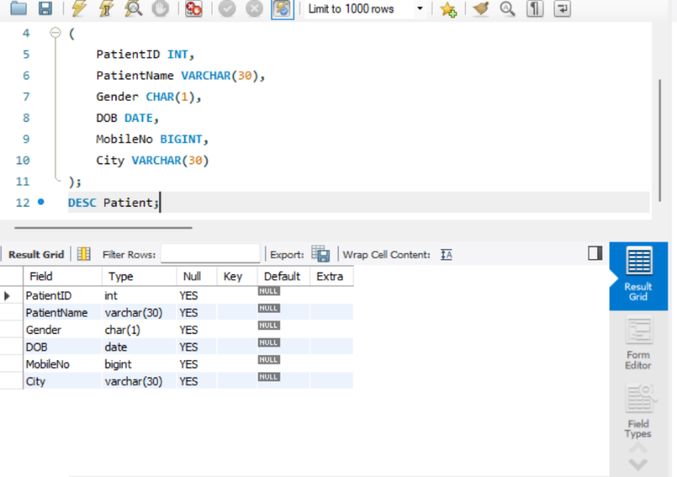

2)Create a table named DOCTOR

CREATE TABLE DOCTOR
(
DoctorID INT,
DoctorName VARCHAR(30),
Gender CHAR(1),
Specialization VARCHAR(30),
MobileNo BIGINT,
Experience INT
);

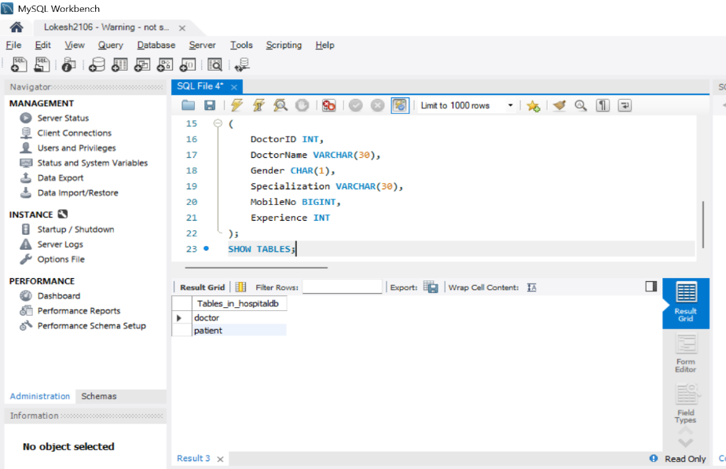
3) Create a table named DEPARTMENT

CREATE TABLE DEPARTMENT
(
DeptID INT,
DeptName VARCHAR(30),
DeptHead VARCHAR(30)
);

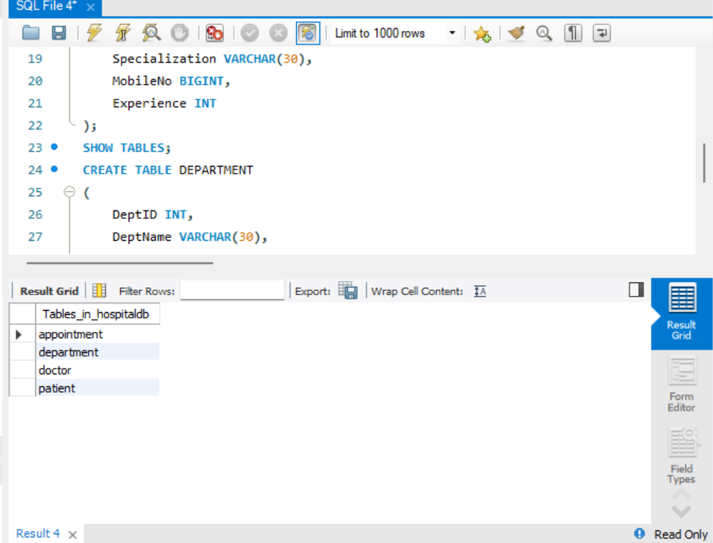

4) Create a table named APPOINTMENT
CREATE TABLE APPOINTMENT
(
AppointmentID INT,
PatientID INT,
DoctorID INT,
AppointmentDate DATE,
AppointmentTime TIME,
RoomNo VARCHAR(10)
);

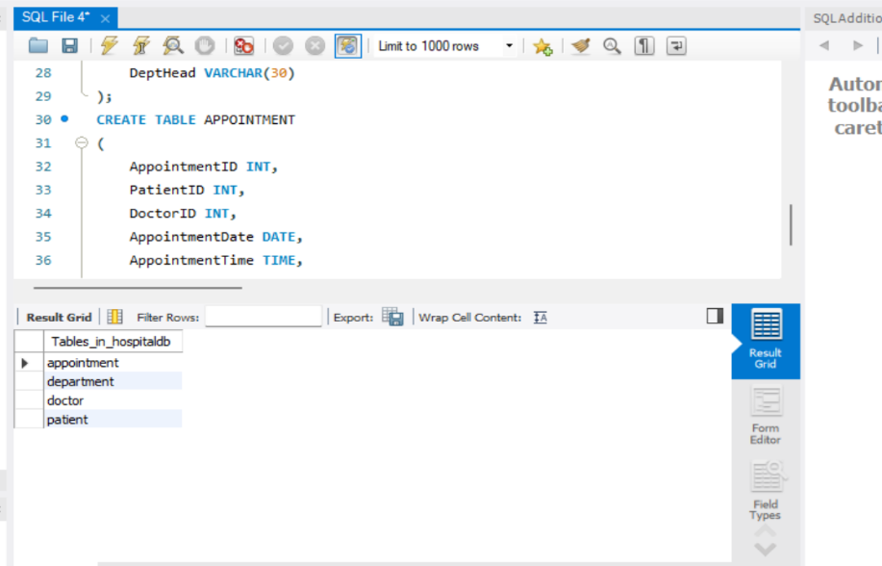
5)Modify the PATIENT table by adding a column named Disease of datatype VARCHAR(30)

ALTER TABLE PATIENT
ADD Disease VARCHAR(30);

